MADHAV INSTITUTE OF TECHNOLOGY AND SCIENCE, GWALIOR

SUBMITTED BY-

ASMITA JAIN

0901EO201017

SUBMITTED TO-

PROF. APRAJITA KUMARI

**SENSOR TECHNOLOGY LAB 220202**

**EXPERIMENT - 6**

**AIM:**

To study the operating principle of Air flow Sensor.

**THEORY:**It consist of 2 RTDs or, 1 RTD and 1 thermistor or any thermal sensors. Out of these 1 is connected to the heater and another is unheated.

RESISTIVE AIR FLOW SENSOR:

The temperature difference will be related to the air

flow rate which will in turn affect the resistance of the RTD’s.

• The differential temperature between the heated sensor element and the ambient temperature sensor element is inversely proportional to the flow rate of the fluid.

• Any change in the flow velocity results in a change in the differential temperature, which is detected as a change in resistances of the two RTD elements.

**CIRCUIT DIAGRAM:**

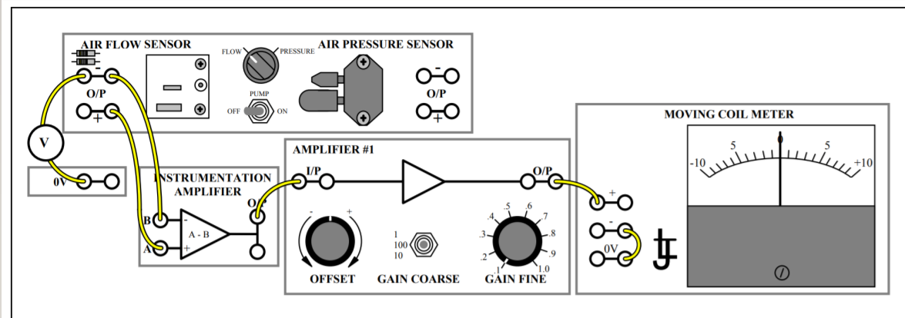

**OBERSERVATION TABLE:**

|  |  |  |
| --- | --- | --- |
|  | Pump off | Pump on |
| Transducer – output voltage | 2.04 V | 1.98 V |
| Transducer + output voltage | 1.71 V | 1.78 V |